What are Models

Steps

Required Library files

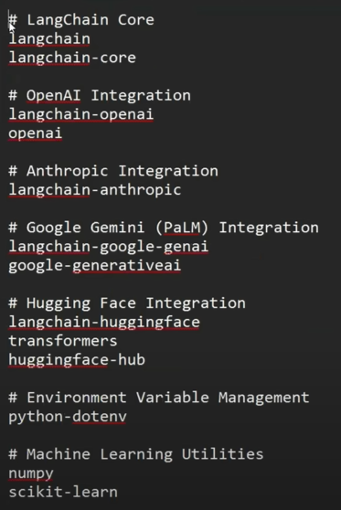

1 OpenAi

1. LLM Code

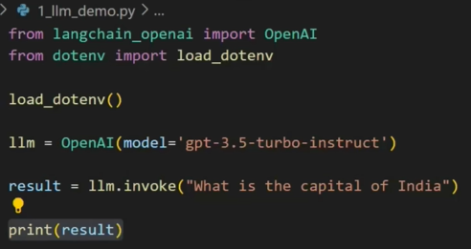

1. Chatmodel

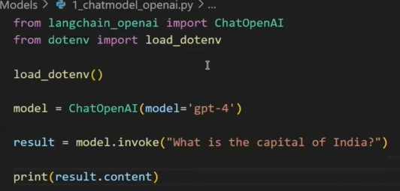





2.Antropic (paid credits)

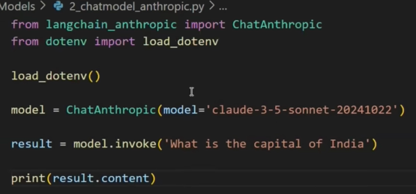

1. Gemini(paid)

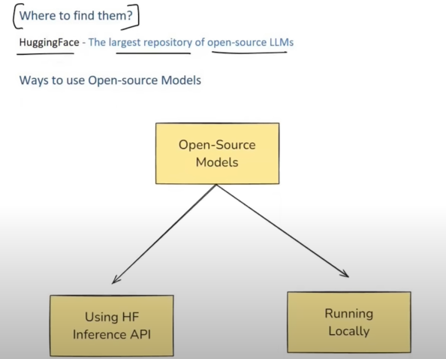

HuggingFace

1. API

1. Local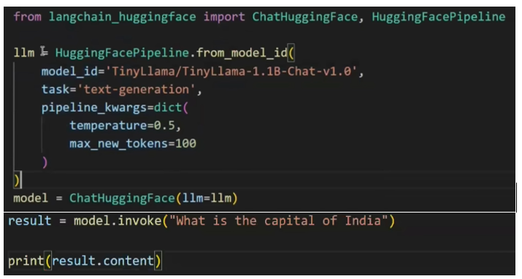

Embedding Models

1.Query

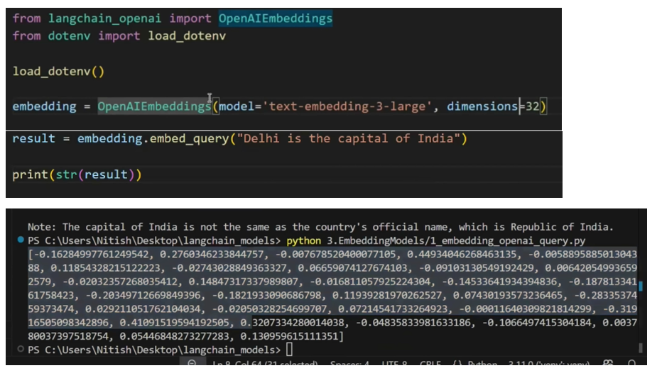

2.Docs

Huggingface - Embedding Models

1. query

1. docs

